LAB REPORT实验报告
Lab Title | Graph |  |  |  | Lab No. | 05
Stud. Name | 蒋云翔 | Major | CST |  | Class
Student ID | 2022102330 |  | Date | 11/16/2023
Lab description/objectives:
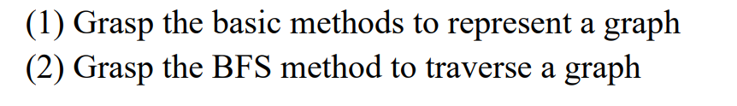
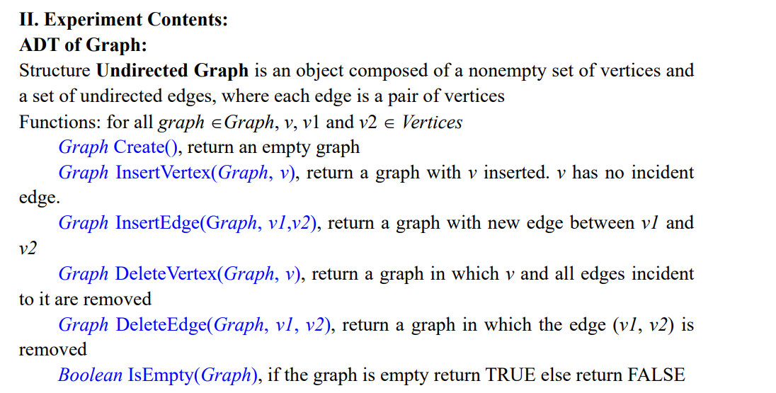
Source code:
①Using adjacent matrix：
#include<stdio.h>
#include<stdbool.h>
#include<stdlib.h>
#include <string.h>

#define MAX_VEX 30

typedef struct
{
int vexnum, arcnum;
/* array saving vertices */
char vexs[MAX_VEX];
/* adjacent matrix*/
int adj[MAX_VEX][MAX_VEX];
}ADMGraph;

typedef struct {
int data[MAX_VEX];
int front, rear;
} Queue;

bool QueueIsEmpty(Queue* q) {
return q->front == q->rear ? true : false;
}

void InitQueue(Queue* q) {
q->front = q->rear = 0;
}

void EnQueue(Queue* q, int value) {
if ((q->rear + 1) % MAX_VEX == q->front) {
printf("Queue is full!\n");
exit(1);
}
q->data[q->rear] = value;
q->rear = (q->rear + 1) % MAX_VEX;
}

int DeQueue(Queue* q) {
if (QueueIsEmpty(q)) {
printf("Queue is empty!\n");
exit(1);
}
int value = q->data[q->front];
q->front = (q->front + 1) % MAX_VEX;
return value;
}

int LocateVex(ADMGraph* G, char ver)
{
int k;
for (k = 0; k < G->vexnum; k++)
{
if (G->vexs[k] == ver)
return k;
if (G->vexs[k] == '0')
return 0;
}

return -1; /* no such vertex in the graph */
}

ADMGraph* Create(ADMGraph* G)
{
G->vexnum = 0;
G->arcnum = 0;
return G;
}

ADMGraph * InsertVertex(ADMGraph* G, char ver[])
{
int k = G->vexnum;
while (ver[k]!= '0') {
if (G->vexnum >= MAX_VEX) { //situation 1: Overflow
printf("Vertex Overflow!\n");
exit(1);
}
if (LocateVex(G, ver[k]) != -1) { //situation 2: Element has existed already
printf("Vertex has existed!\n");
exit(1);
}
if (k >= MAX_VEX) { //situation 3: buffer overflow
printf("Vertex Overflow!\n");
exit(1);
}
G->vexs[k] = ver[k];
G->vexnum++;
k++;

}
return G;
}

ADMGraph *InsertEdge(ADMGraph* G, char v1, char v2) {
int i, j;

i = LocateVex(G,v1);
j = LocateVex(G,v2);
if (i == -1 || j == -1)
{
printf("Arc's Vertex do not existed !\n");
exit(1);
}
G->arcnum++;
G->adj[i][j] = 1;
G->adj[j][i] = 1;
return G;
}

ADMGraph *DeleteVertex(ADMGraph* G, char v)
{
int i = LocateVex(G, v);
// update the adjacent matrix
// update the column of the matrix
if (i == G->vexnum) goto flag; // the element is the last vertex
for (int j = 0; j < G->vexnum ;j++)
{
if (G->adj[j][i] ==1) G->arcnum--; // The corresponding value in the matrix euals to 1 which means there is and arc between two vertexs
for (int s = i; s < G->vexnum - 1; s++) {
G->adj[j][s] = G->adj[j][s + 1];
}
}
//update the row of the matix
for (int a = 0; a < G->vexnum; a++)
{
for (int b = i; b < G->vexnum - 1; b++) {
G->adj[b][a] = G->adj[b + 1][a];
}
}

flag:
// update the vexs array
for (i; i < G->vexnum - 1; i++) {
G->vexs[i] = G->vexs[i + 1];
}
G->vexs[G->vexnum - 1] = '\0';
G->vexnum--;

return G;
}

ADMGraph* DeleteEdge(ADMGraph* G, char v1, char v2) {
int i = LocateVex(G, v1);
int j = LocateVex(G, v2);
G->adj[i][j] = 0;
G->adj[j][i] = 0;
G->arcnum--;
return G;
}

bool IsEmpty(ADMGraph* G)
{
return G->vexnum == 0 ? 1 : 0;
}

void Bfs_Traverse(ADMGraph* G, char startVertex, bool visited[])
{
int startIndex = LocateVex(G, startVertex);
if (startIndex == -1)
{
printf("Start Vertex does not exist!\n");
exit(1);
}

Queue q; // By using data structure 'Queue'
InitQueue(&q);
visited[startIndex] = true; // Mark it to show it has been visited
printf("%c", G->vexs[startIndex]);

EnQueue(&q, startIndex); // enqueue the start vertex

while (!QueueIsEmpty(&q))
{
int index = DeQueue(&q);
for (int i = 0; i < G->vexnum; i++)
{
if (G->adj[index][i] == 1 && !visited[i]) // If there is a edge and it has not been visited
{
visited[i] = true; // Mark it as true if it has been visited
printf("%c", G->vexs[i]);
EnQueue(&q, i);
}
}
}
}

bool InitializeVisited(int visited[], int size)
{
for (int i = 0; i < size; i++)
{
visited[i] = false;
}
}

int main() {
ADMGraph G;
Create(&G);
char input1[MAX_VEX];
char input2[MAX_VEX];

printf("Please enter the vertices: ");
scanf("%s", input1);
InsertVertex(&G, input1);

printf("Please enter the pairs: ");
scanf("%s", input2);

int index = 0;
while (input2[index] != '0') {
char v1 = input2[index];
char v2 = input2[index + 1];
InsertEdge(&G, v1, v2);
index += 2;
}

bool visited[MAX_VEX];
InitializeVisited(visited, G.vexnum);
Bfs_Traverse(&G, 'A', visited);
printf("\n");
DeleteVertex(&G, 'B');
printf("Delete vertex 'B'!\n");
InitializeVisited(visited, G.vexnum);
Bfs_Traverse(&G, 'A', visited);
printf("\n");
if (!IsEmpty(&G)) printf("It is not empty!\n");
else printf("It is empty!\n");
DeleteVertex(&G, 'A');
DeleteVertex(&G, 'C');
DeleteVertex(&G, 'D');
DeleteVertex(&G, 'E');
DeleteVertex(&G, 'F');
DeleteVertex(&G, 'G');
printf("Delete all vertices!\n");
if (!IsEmpty(&G)) printf("It is not empty!\n");
else printf("It is empty!\n");

return 0;
}
Using adjacent list:
#include<stdio.h>
#include<stdbool.h>
#include<stdlib.h>
#include <string.h>

#define MAX_VEX 30

typedef struct
{
int vexnum, arcnum;
/* array saving vertices */
char vexs[MAX_VEX];
/* adjacent matrix*/
int adj[MAX_VEX][MAX_VEX];
}ADMGraph;

typedef struct {
int data[MAX_VEX];
int front, rear;
} Queue;

bool QueueIsEmpty(Queue* q) {
return q->front == q->rear ? true : false;
}

void InitQueue(Queue* q) {
q->front = q->rear = 0;
}

void EnQueue(Queue* q, int value) {
if ((q->rear + 1) % MAX_VEX == q->front) {
printf("Queue is full!\n");
exit(1);
}
q->data[q->rear] = value;
q->rear = (q->rear + 1) % MAX_VEX;
}

int DeQueue(Queue* q) {
if (QueueIsEmpty(q)) {
printf("Queue is empty!\n");
exit(1);
}
int value = q->data[q->front];
q->front = (q->front + 1) % MAX_VEX;
return value;
}

int LocateVex(ADMGraph* G, char ver)
{
int k;
for (k = 0; k < G->vexnum; k++)
{
if (G->vexs[k] == ver)
return k;
if (G->vexs[k] == '0')
return 0;
}

return -1; /* no such vertex in the graph */
}

ADMGraph* Create(ADMGraph* G)
{
G->vexnum = 0;
G->arcnum = 0;
return G;
}

ADMGraph * InsertVertex(ADMGraph* G, char ver[])
{
int k = G->vexnum;
while (ver[k]!= '0') {
if (G->vexnum >= MAX_VEX) { //situation 1: Overflow
printf("Vertex Overflow!\n");
exit(1);
}
if (LocateVex(G, ver[k]) != -1) { //situation 2: Element has existed already
printf("Vertex has existed!\n");
exit(1);
}
if (k >= MAX_VEX) { //situation 3: buffer overflow
printf("Vertex Overflow!\n");
exit(1);
}
G->vexs[k] = ver[k];
G->vexnum++;
k++;

}
return G;
}

ADMGraph *InsertEdge(ADMGraph* G, char v1, char v2) {
int i, j;

i = LocateVex(G,v1);
j = LocateVex(G,v2);
if (i == -1 || j == -1)
{
printf("Arc's Vertex do not existed !\n");
exit(1);
}
G->arcnum++;
G->adj[i][j] = 1;
G->adj[j][i] = 1;
return G;
}

ADMGraph *DeleteVertex(ADMGraph* G, char v)
{
int i = LocateVex(G, v);
// update the adjacent matrix
// update the column of the matrix
if (i == G->vexnum) goto flag; // the element is the last vertex
for (int j = 0; j < G->vexnum ;j++)
{
if (G->adj[j][i] ==1) G->arcnum--; // The corresponding value in the matrix euals to 1 which means there is and arc between two vertexs
for (int s = i; s < G->vexnum - 1; s++) {
G->adj[j][s] = G->adj[j][s + 1];
}
}
//update the row of the matix
for (int a = 0; a < G->vexnum; a++)
{
for (int b = i; b < G->vexnum - 1; b++) {
G->adj[b][a] = G->adj[b + 1][a];
}
}

flag:
// update the vexs array
for (i; i < G->vexnum - 1; i++) {
G->vexs[i] = G->vexs[i + 1];
}
G->vexs[G->vexnum - 1] = '\0';
G->vexnum--;

return G;
}

ADMGraph* DeleteEdge(ADMGraph* G, char v1, char v2) {
int i = LocateVex(G, v1);
int j = LocateVex(G, v2);
G->adj[i][j] = 0;
G->adj[j][i] = 0;
G->arcnum--;
return G;
}

bool IsEmpty(ADMGraph* G)
{
return G->vexs == 0 ? 1 : 0;
}

void Bfs_Traverse(ADMGraph* G, char startVertex, bool visited[])
{
int startIndex = LocateVex(G, startVertex);
if (startIndex == -1)
{
printf("Start Vertex does not exist!\n");
exit(1);
}

Queue q; // By using data structure 'Queue'
InitQueue(&q);
visited[startIndex] = true; // Mark it to show it has been visited
printf("%c", G->vexs[startIndex]);

EnQueue(&q, startIndex); // enqueue the start vertex

while (!QueueIsEmpty(&q))
{
int index = DeQueue(&q);
for (int i = 0; i < G->vexnum; i++)
{
if (G->adj[index][i] == 1 && !visited[i]) // If there is a edge and it has not been visited
{
visited[i] = true; // Mark it as true if it has been visited
printf("%c", G->vexs[i]);
EnQueue(&q, i);
}
}
}
}

bool InitializeVisited(int visited[], int size)
{
for (int i = 0; i < size; i++)
{
visited[i] = false;
}
}

int main() {
ADMGraph G;
Create(&G);

char input1[MAX_VEX];
char input2[MAX_VEX];

printf("Please enter the vertices: ");
scanf("%s", input1);
InsertVertex(&G, input1);

printf("Please enter the pairs: ");
scanf("%s", input2);

int index = 0;
while (input2[index] != '0') {
char v1 = input2[index];
char v2 = input2[index + 1];
InsertEdge(&G, v1, v2);
index += 2;
}

bool visited[MAX_VEX];
InitializeVisited(visited, G.vexnum);
Bfs_Traverse(&G, 'A', visited);

return 0;
}
Program outputs:
Normal output:
Adjacent matrix:
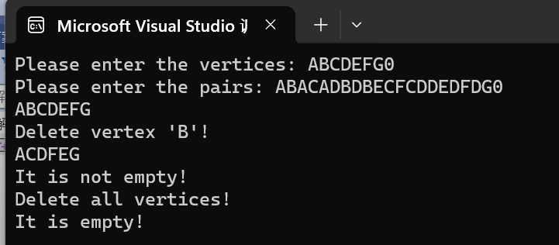

Adjacent List:
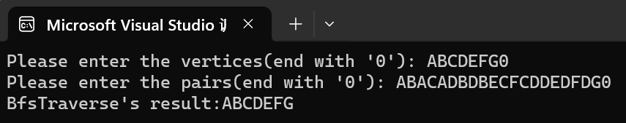

Analysis:
Part1：
Actually, there exists a various of error situation in these 2 kinds of methods to represent the graph. Let’s discuss about them!

Error situation 1: Input the repeated vertex
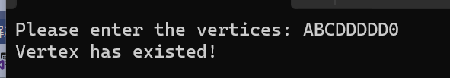

Error situation 2:The number of input vertices are larger than the array
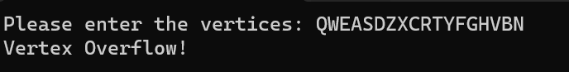

Error situation 3: The edge’s corresponding vertex does not exist
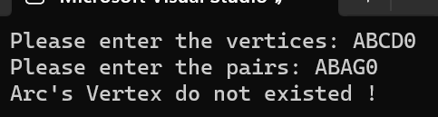

Error situation 4: The start vertex used for BFS does not exist
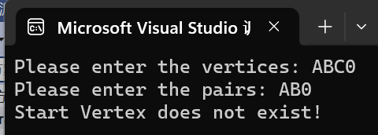

Part2：
Time complexity analysis：
Adjacent matrix：O(V^2)
Adjacent list：O(V + E)

Space complexity：
